Calculator Free
Integration, Fundamental Theorem of Calculus, Area

Time: 45 minutes
Total Marks: 45
Your Score: / 45



Question One: [2, 2, 2, 2 =8 marks] CF

- Calculate

- Use your answer to part (a) to evaluate , in terms of x

- Use your answer to part (b) to evaluate

- Hence evaluate

Question Two: [2, 2, 2 = 6 marks] CF
Determine each of the following:

Question Three: [2, 3, 2 = 7 marks] CF
Consider the function drawn below over the domain
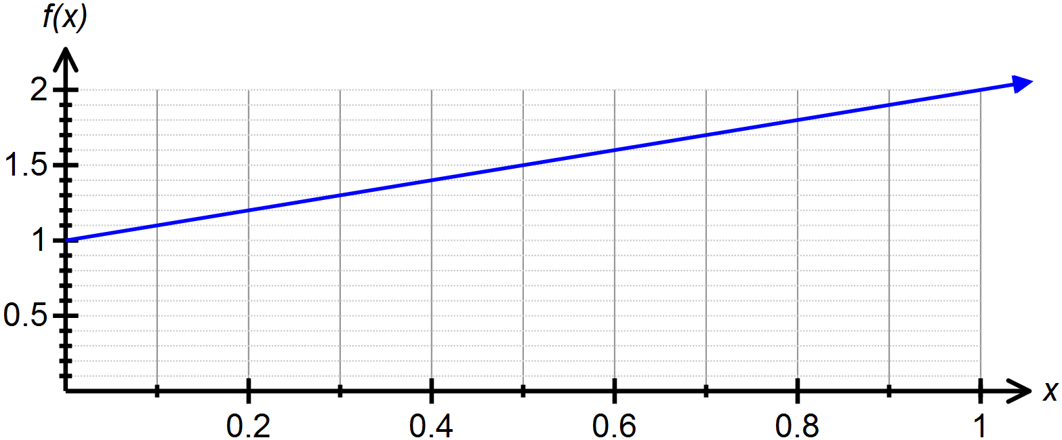

- Draw rectangles on your graph that can be used to underestimate the area under over the domain , where .

- Show that

- Use the graph of above to calculate

Question Four: [4, 5 = 9 marks] CF
Consider the function
- Determine the roots of the function.

- Hence determine the area bounded by the curve and the x – axis.

Question Five: [1, 2, 4 = 7 marks] CF
The functions and are drawn below.
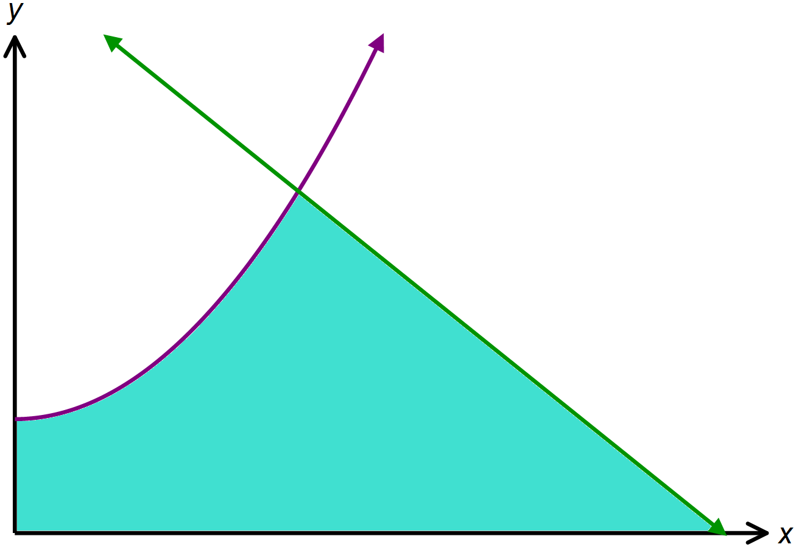

- Solve

- Solve

- Hence find the area shaded on the graph above.

Question Six: [3, 5 = 8 marks] CF
The curve and the tangent line at are graphed below.
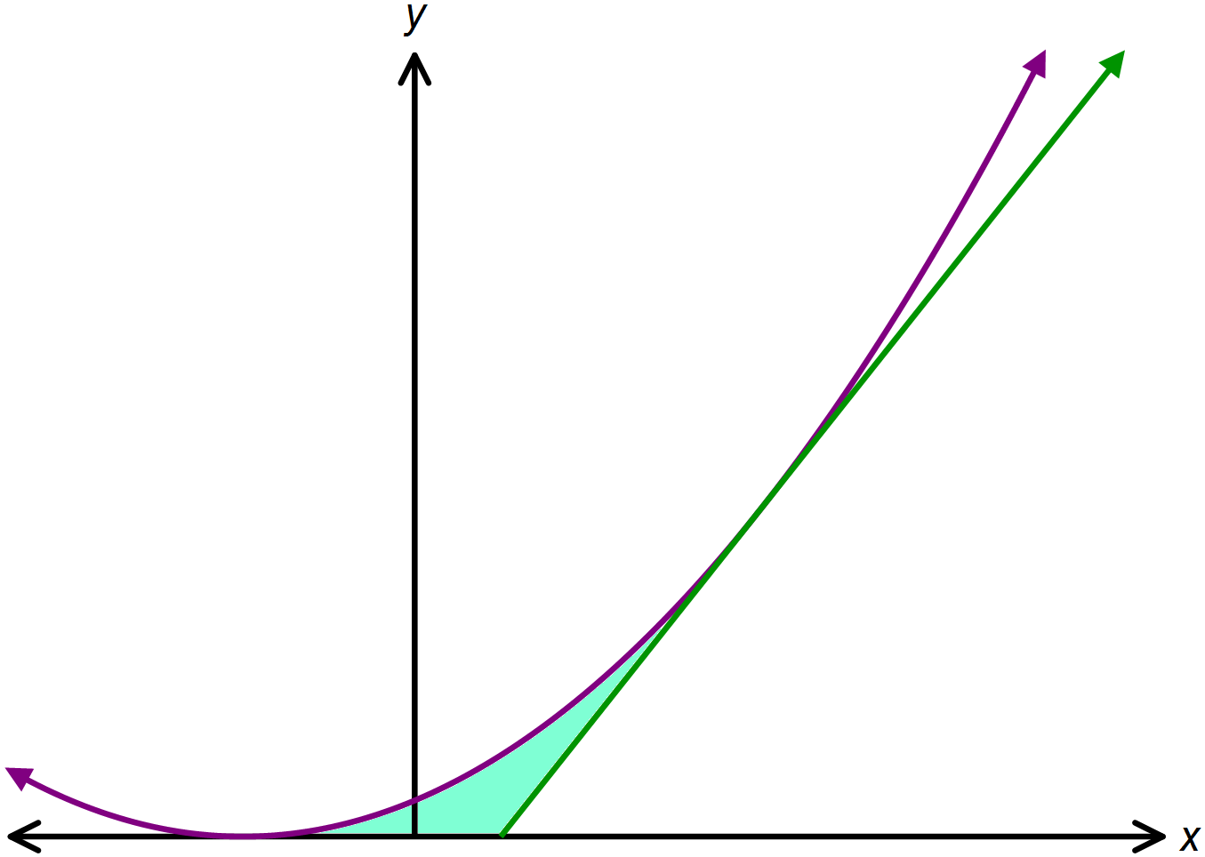

- Determine the equation of the tangent to drawn above.

- Hence find the area shaded on the graph above.

SOLUTIONS
Calculator Free
Integration, Fundamental Theorem of Calculus, Area

Time: 45 minutes
Total Marks: 45
Your Score: / 45



Question One: [2, 2, 2, 2 =8 marks] CF


- Calculate

- Use your answer to part (a) to evaluate , in terms of x


- Use your answer to part (b) to evaluate



- Hence evaluate

Question Two: [2, 2, 2 = 6 marks] CF
Determine each of the following:






Question Three: [2, 3, 2 = 7 marks] CF
Consider the function drawn below over the domain
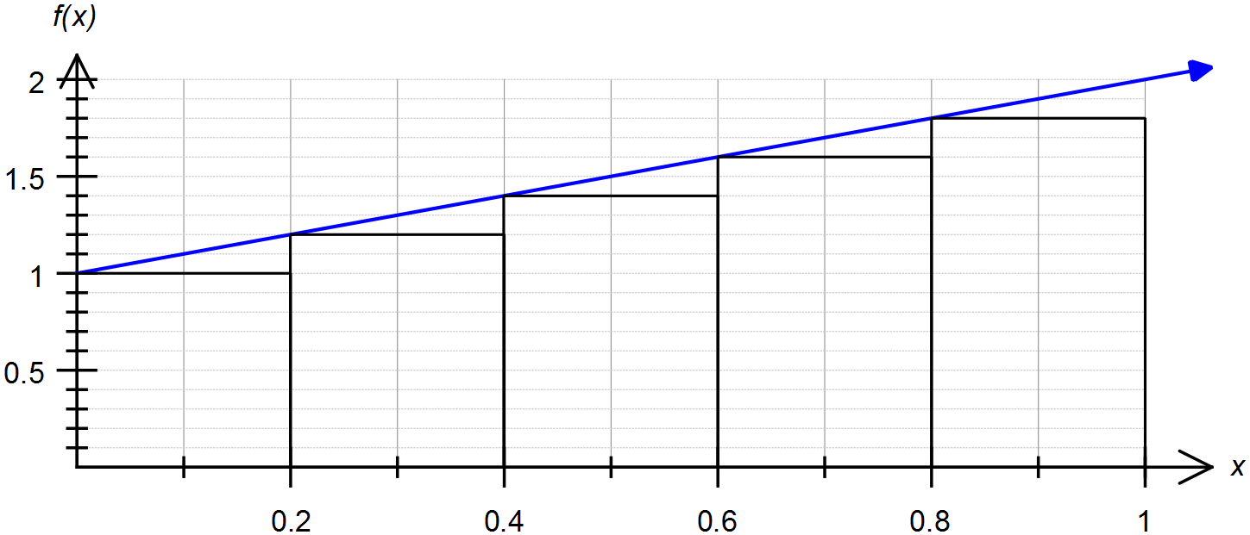




- Draw rectangles on your graph that can be used to underestimate the area under over the domain , where .

- Show that



- Use the graph of above to calculate


Question Four: [4, 5 = 9 marks] CF
Consider the function
- Determine the roots of the function.





- Hence determine the area bounded by the curve and the x – axis.





Question Five: [1, 2, 4 = 7 marks] CF
The functions and are drawn below.


- Solve

- Solve



- Hence find the area shaded on the graph above.




Question Six: [3, 5 = 8 marks] CF
The curve and the tangent line at are graphed below.


- Determine the equation of the tangent to drawn above.





- Hence find the area shaded on the graph above.




